Department | FED
Subject | DSA-2
Academic Year | I-III Semester(2025-26)
Faculty Name | BALAIAH SIR
Student Name | V.CHARISHMA
Roll Number | 2520030140
Branch | CSE
Course Outcome | 6

Case Study Topic: Steel-Mill Rod-Cutting Profit Maximization using Dynamic Programming
Work Done Summary:
- Analyzed the steel rod cutting problem using Dynamic Programming.
- Considered a 10-foot steel rod and given price table.
- Applied the rod-cutting recurrence relation.
- Constructed the DP table from length 0 to 10.
- Calculated maximum revenue for each rod length.
- Stored optimal first cuts for reconstruction.
- Identified the optimal cut sequence.
- Compared top-down memoization and bottom-up tabulation approaches.
- Studied the relationship between rod-cutting and unbounded knapsack.
- Evaluated variants such as bounded cutting and cutting-with-cost.

Implementation Details:
- Initialized the price array:
- [0,1,5,8,9,10,17,17,20,24,30]
- Created a DP array to store maximum revenue for each rod length.
- Set dp[0] = 0 as the base case.
- Applied the recurrence:
- dp[i] = max(price[k] + dp[i-k])
- Computed dp[1] through dp[10] iteratively.
- Stored the first optimal cut for each rod length.
- Constructed the complete DP table.
- Backtracked using the cut array to obtain the optimal cut sequence.
- Determined the maximum revenue for a 10-foot rod.
- Verified the solution using Dynamic Programming.
Result: Screenshots / Output
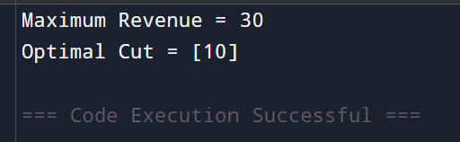
The Dynamic Programming approach successfully computed the maximum obtainable revenue from the steel rod.

Time Complexity :
Timsort:
O(n²)
Space Complexity:
O(n)
GitHub Link: https://github.com/virodulacharishma0506-del/DSA--2-Project/blob/main/max.java
Student Signature | Faculty Signature

